**KUBERNETES TASK 4**

1. Deploy an application using a Deployment with 3 replicas and a rolling update strategy.

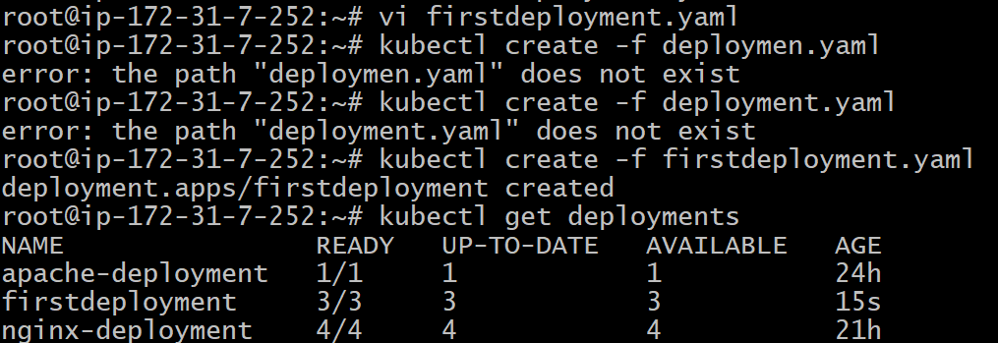

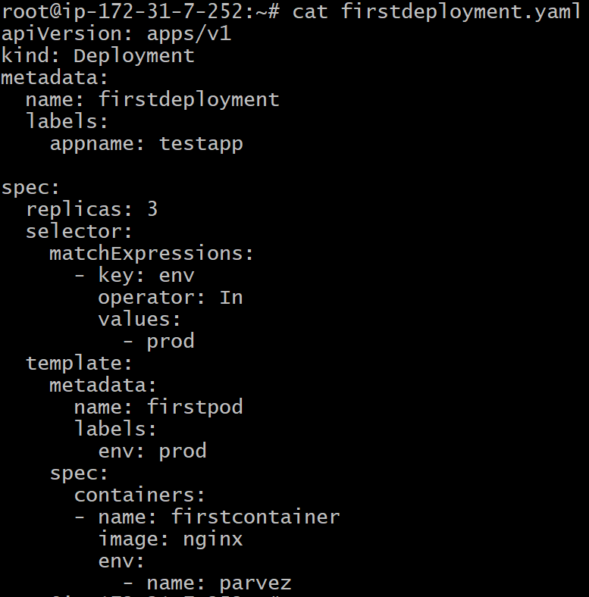

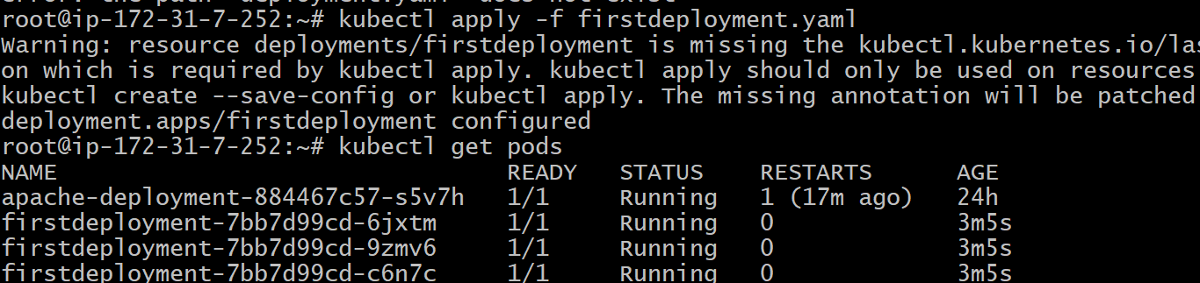

Update and rolled out

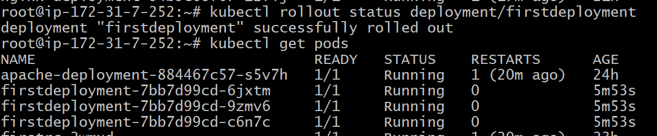

1. Configure a Deployment with a Recreate strategy and observe the downtime.

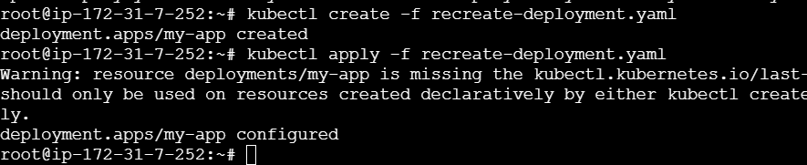

Observing the downtime strategy and it is pulled image backoff

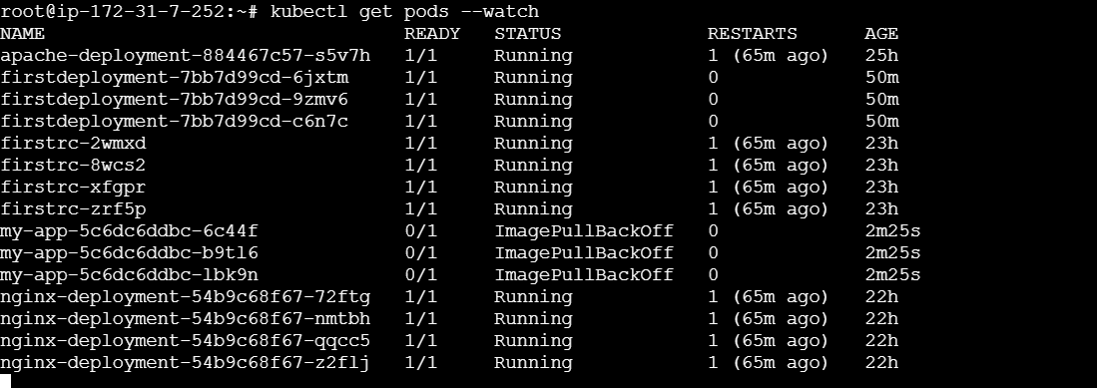

1. Update an existing Deployment and perform a rollback to the previous version.

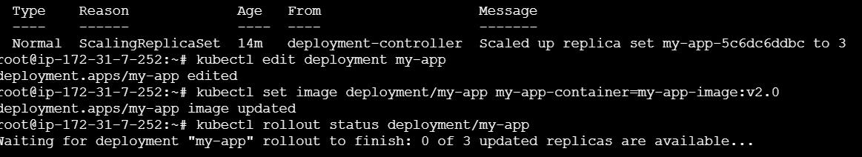

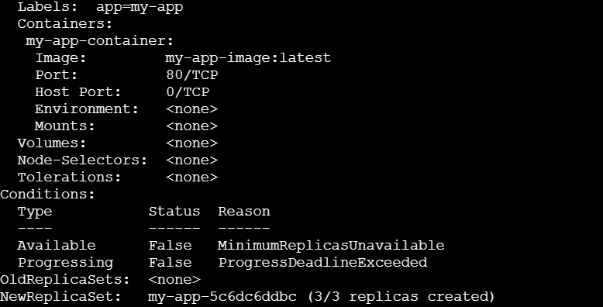

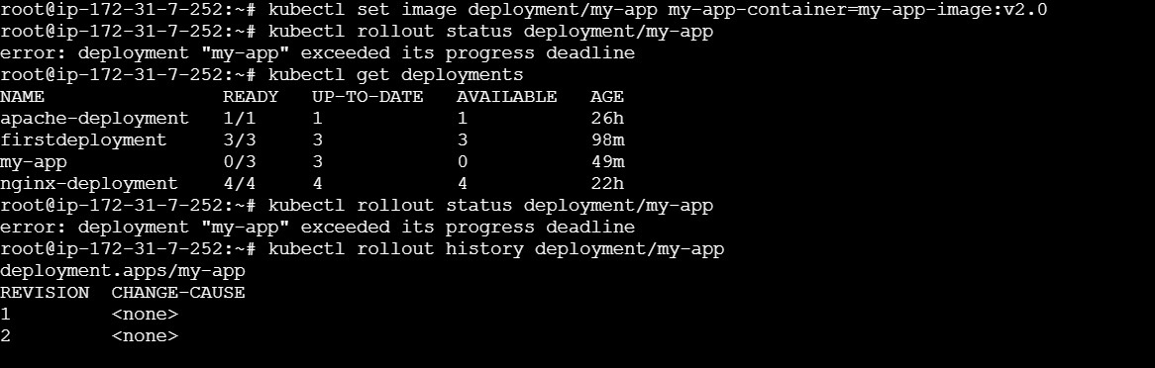

1. Modify a Deployment to add resource requests and limits for CPU and memory.

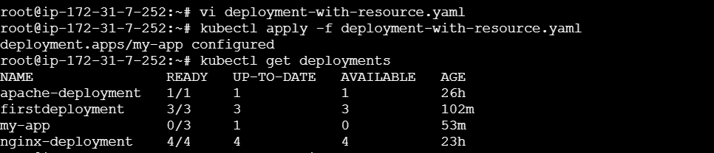

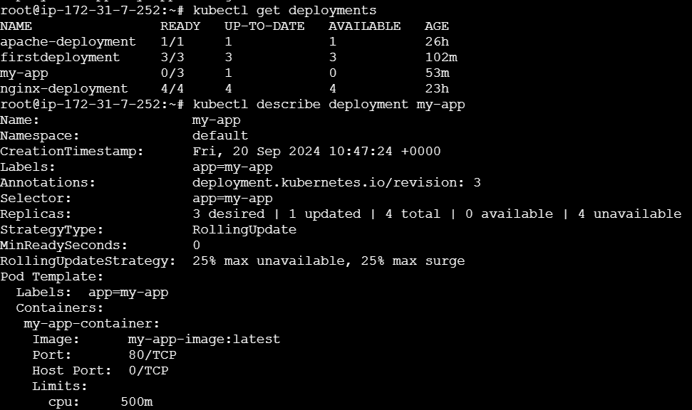

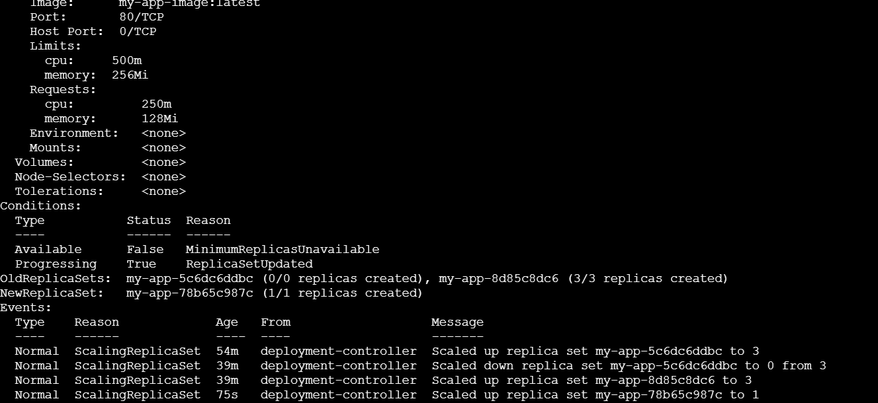

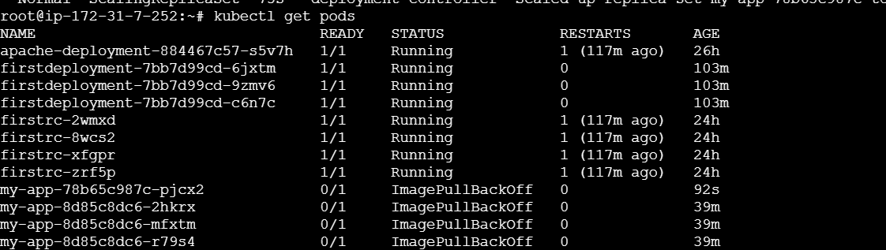

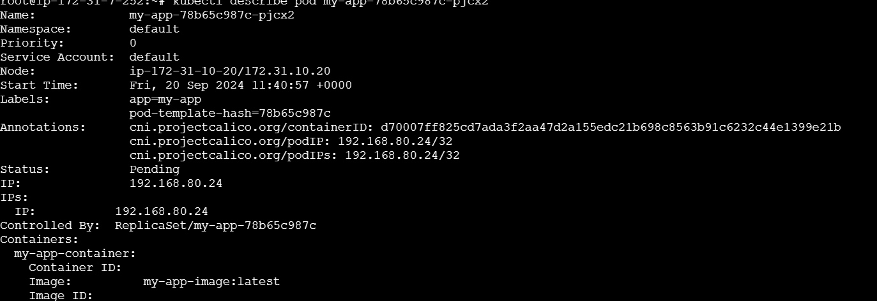

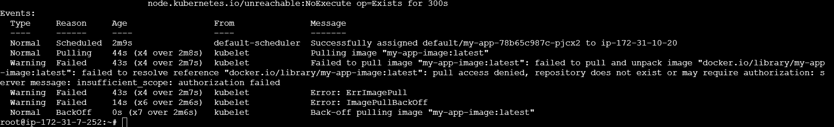

1. Create a Deployment with MaxSurge and MaxUnavailable configurations.

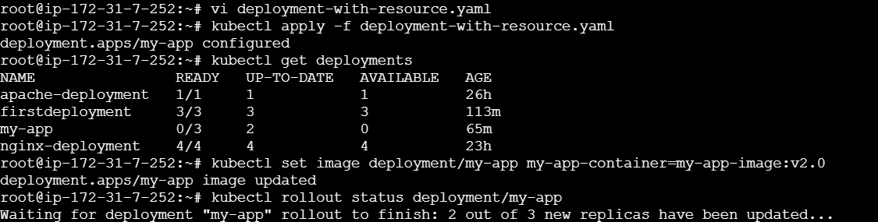

1. Set up a Deployment with a custom revision history limit.

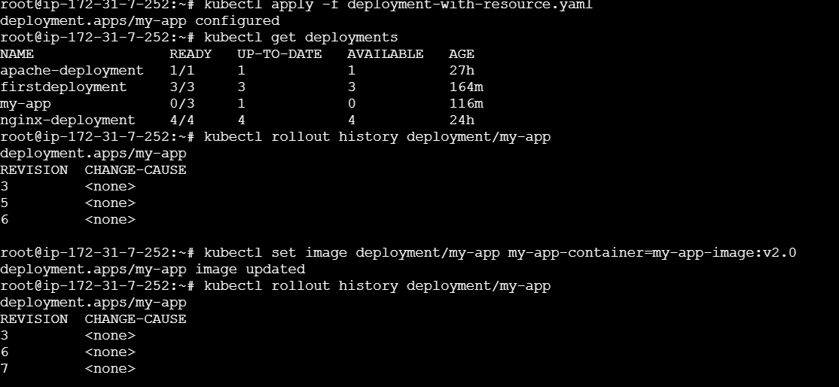

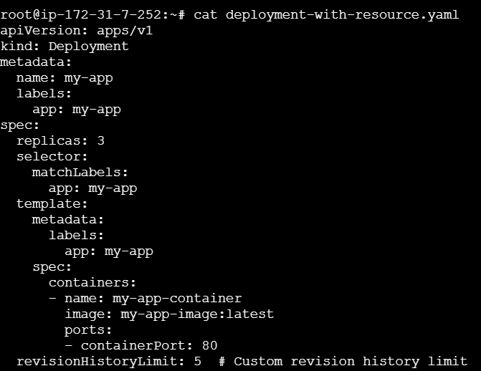



1. Pause a Deployment during an update, and then resume it.

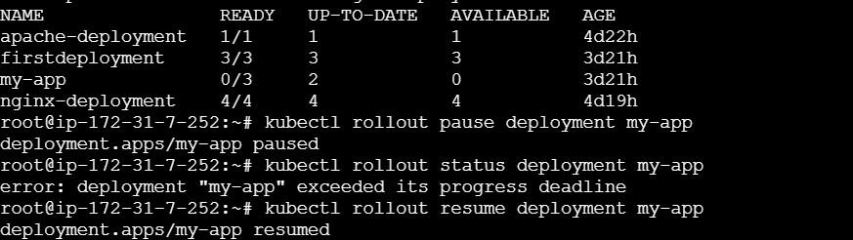

8)Create a pod using resource requests for memory and CPU, and observe how the scheduler assigns it to a node.



